Create a Tic-Tac-Start plugin

Welcome in this tutorial ! I will teach you how to create a Tic-Tac-Start plugin that will match an action. The language to create this plugin will be C# !

**A plugin contains 2 elements :**

* A main class in which you will develop the goal of the plugin

(ex : Play a sound)

* A WinForm or a WPF Window which will enable the user to give values to the arguments (parameters) of the main function.

**The main class will contain :**

* The main function of the plugin (action) which will be called by Tic-Tac-Start. This function will be *public* and static. You can use parameters (arguments).

**The WindowsForm or the WPF Window will contains:**

* A function *public* which will return an array of object and will obligatory be named "GetParameters". It will have no argument ! This function will return the values entered by the user. This values will be used to call the main function, these will be the values of the parameters.
* A button whose the “**DialogResult**” propriety is set on “OK” (In WPF Window, this button will set the “**DialogResult**” property of the window to "true")

**Concrete example :**

To understand well, we will create a plugin together. This plugin will play a sound file in .wav format.

1. **In Visual Studio, create a class library** !

*(mine is named “MyPlugin”)*

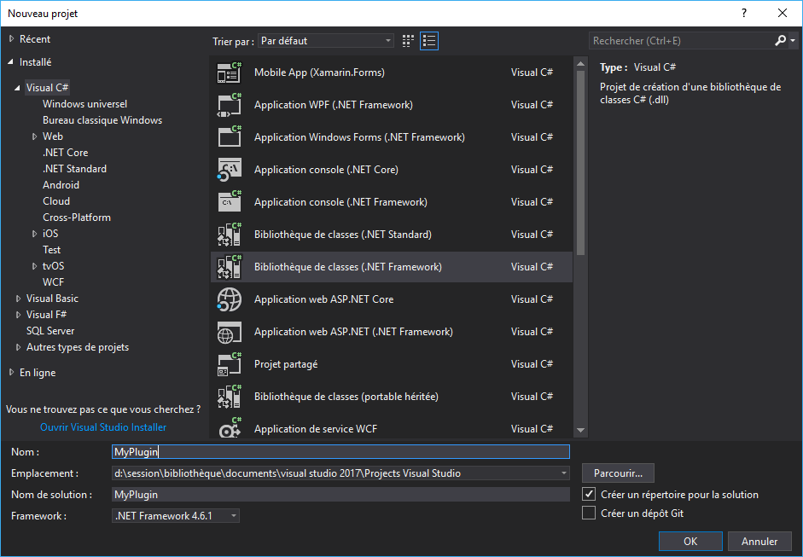

1. **Create the main class of the plugin !** *(mine is named “PlaySound”)*

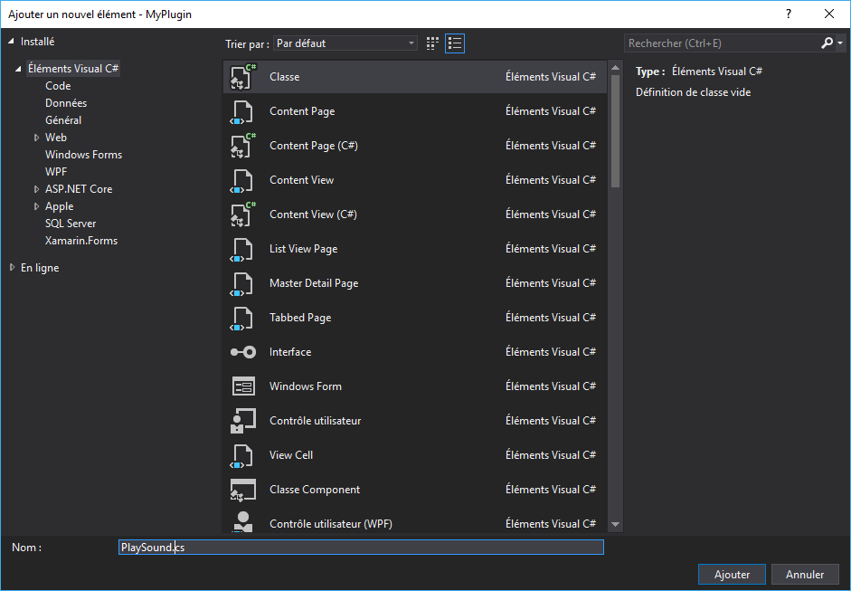

1. **Create the main function *public* and *static* !** *(mine is named “Play”)*

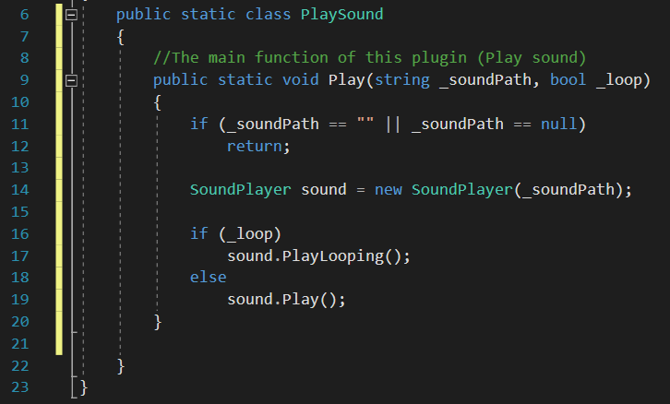

For me it has 2 parameters : One String for the sound file location and one boolean too know if we play the sound over and over or not.

1. **Create a WinForm or a WPF Window !** *(mine is named “PlaySound_ParamsDialog”. It's a WinForm)*

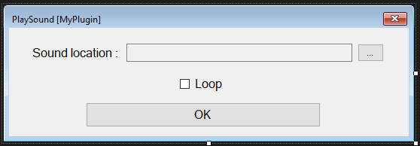

1. **DialogResult**
2. If you use a WindowsForm :   
   **Set the "*DialogResult*" property of button to "*OK*"** !



1. If you use a WPF Window :  
   **Create the "click" event for the button and copy this code !**

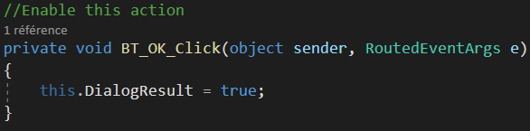

1. **Create the “GetParameters” function in this window !**

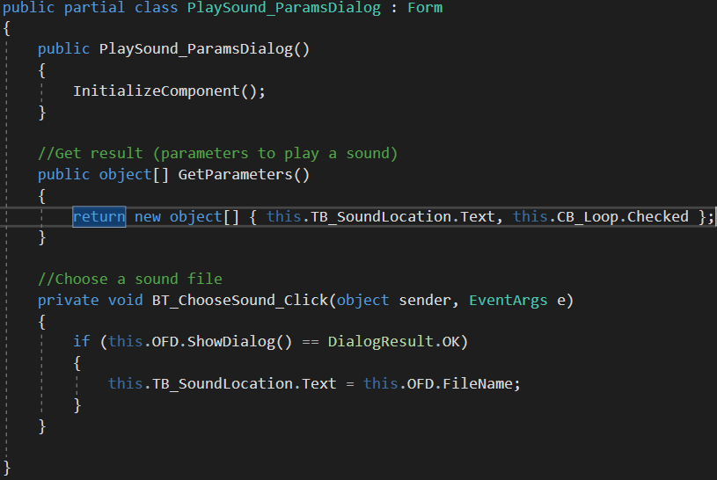

The values of the array correspond to the parameters (in order) of the main function (String, bool).

1. **Generate a DLL !**

Go to generate 🡪 generate the solution

1. **End of the development ! Return to Tic-Tac-Start !**

Go to Mode 🡪 add a plugin

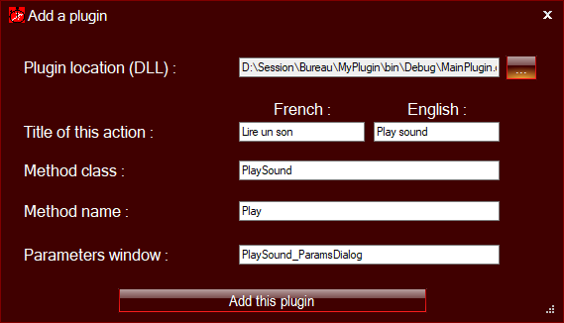

1. **After having filled all the fields, press on “Add this plugin” !**

Your plugin should appear in the actions list.

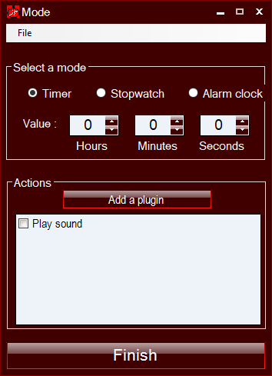

1. **You can use your plugin (action) like others plugins !**

If you activate your plugin, the window you created will appear.

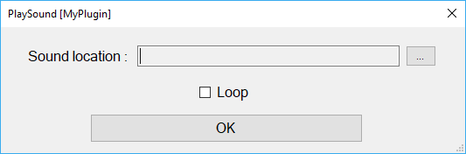

If your plugin use other dll, copy this dll in the folder where is the .exe of Tic-Tac-Start.

You can now create your own Tic-Tac-Start plugin. If you come across any problem, contact me !

My web site : https://admansoftware.wordpress.com